| Experiment No.3 |
| --- |
| Apply Stop Word Removal on given English and Indian Language Text |
| Date of Performance: |
| Date of Submission: |

**Aim:** Apply Stop Word Removal on given English and Indian Language Text.

**Objective:** To write program for Stop word removal from a sentence given in English and any Indian Language.

**Theory:**

The process of converting data to something a computer can understand is referred to as pre-processing. One of the major forms of pre-processing is to filter out useless data. In natural language processing, useless words (data), are referred to as stop words.

Stopwords are the most common words in any natural language. For the purpose of analyzing text data and building NLP models, these stopwords might not add much value to the meaning of the document.

Stop Words: A stop word is a commonly used word (such as “the”, “a”, “an”, “in”) that a search engine has been programmed to ignore, both when indexing entries for searching and when retrieving them as the result of a search query. We need to perform tokenization before removing any stopwords.

**Why do we need to Remove Stopwords?**

Removing stopwords is not a hard and fast rule in NLP. It depends upon the task that we are working on. For tasks like text classification, where the text is to be classified into different categories, stopwords are removed or excluded from the given text so that more focus can be given to those words which define the meaning of the text.

Here are a few key benefits of removing stopwords:

* On removing stopwords, dataset size decreases and the time to train the model also decreases
* Removing stopwords can potentially help improve the performance as there are fewer and only meaningful tokens left. Thus, it could increase classification accuracy
* Even search engines like Google remove stopwords for fast and relevant retrieval of data from the database

We can remove stopwords while performing the following tasks:

* Text Classification
  + Spam Filtering
  + Language Classification
  + Genre Classification
* Caption Generation
* Auto-Tag Generation

**Avoid Stopword Removal**

* Machine Translation
* Language Modeling
* Text Summarization
* Question-Answering problems

**Different Methods to Remove Stopwords**

1. **Stopword Removal using NLTK**

NLTK, or the Natural Language Toolkit, is a treasure trove of a library for text preprocessing. It’s one of my favorite Python libraries. NLTK has a list of stopwords stored in 16 different languages.

You can use the below code to see the list of stopwords in NLTK:

import nltk

from nltk.corpus import stopwords

set(stopwords.words('english'))

1. **Stopword Removal using spaCy:**

**spaCy** is one of the most versatile and widely used libraries in NLP. We can quickly and efficiently remove stopwords from the given text using SpaCy.

It has a list of its own stopwords that can be imported as **STOP_WORDS** from the **spacy.lang.en.stop_words** class.

1. **Stopword Removal using Gensim**

**Gensim** is a pretty handy library to work with on NLP tasks. While pre-processing, gensim provides methods to remove stopwords as well. We can easily import the remove_stopwords method from the class gensim.parsing.preprocessing.

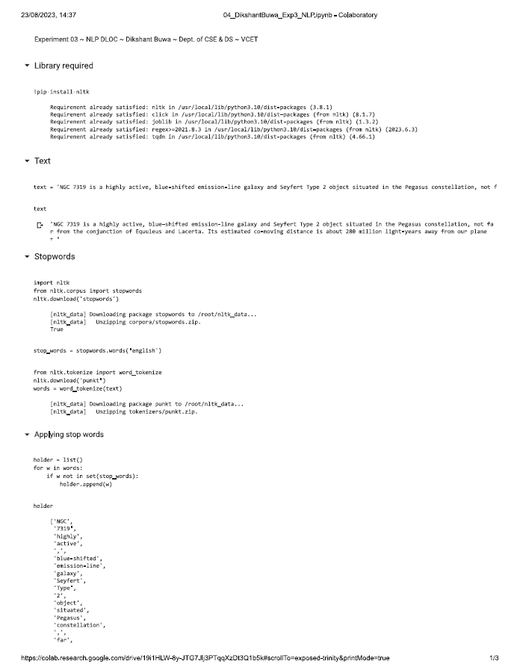

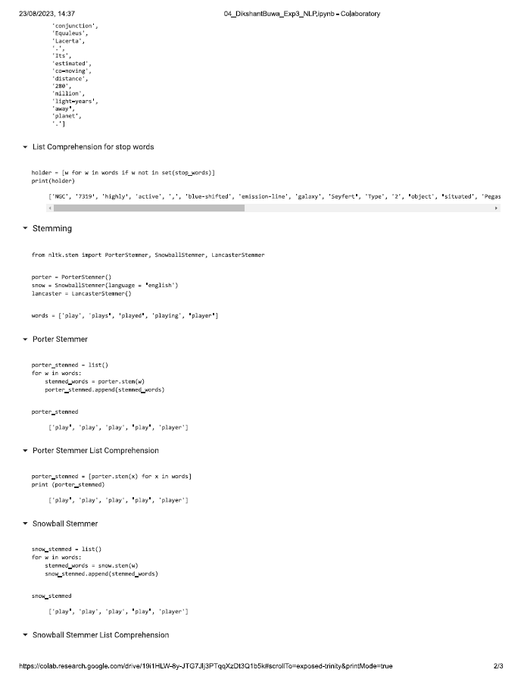

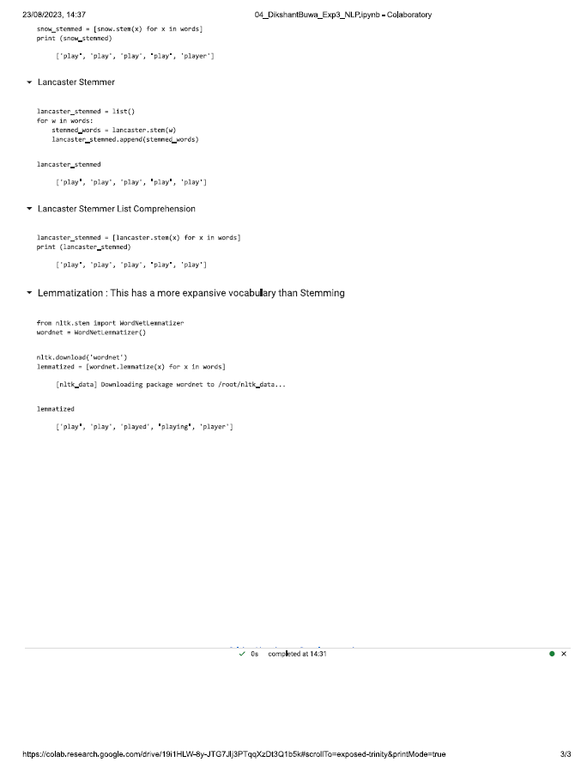

**Conclusion:**

Tools used for stop word removal of Indian language are:

1. NLTK (Natural Language Toolkit): NLTK is a popular Python library that provides support for multiple languages, including Indian languages. You can use NLTK to perform tokenization and stop word removal.

2. spaCy: spaCy is another NLP library for Python that supports various languages, including some Indian languages. It has pre-trained models and stop word lists for languages like Hindi and Bengali.

3. IndicNLP Library: The IndicNLP Library for Python is a valuable resource for text processing in various Indian languages. It includes tokenization, stop word removal, and other NLP tasks specifically designed for Indian languages.

4. Voyce Text Analysis Toolkit: Voyce is a text analysis toolkit developed for Indian languages, including Hindi, Telugu, and Kannada. It offers various text preprocessing and analysis functions, making it suitable for stop word removal.

Steps involved in stop word removal:

1. Tokenization: Break the text into individual words or tokens using language-specific tokenization methods or libraries.

2. Stop Word List: Obtain or create a list of stop words for the specific Indian language you are working with. Stop words are common words with low semantic value, such as "and," "the," "in," etc.

3. Text Preprocessing: For each token in the text:

a. Check if the token matches any of the stop words from your stop word list.

b. If a match is found, mark the token for removal.

c. If no match is found, keep the token for further processing.

4. Stop Word Removal: Remove the marked stop words from the text, leaving only the meaningful content words.